Incident Management Process

Security Classification: Protected

Document Ref. ISMS22002
Version: 1.0
Draft 1

Document Author: Cybersecurity Unit

Document Owner: NCS/ TMP

Revision History

Version | Date | Change Number | Summary of Changes
1.0 |  | Draft 1 | Tailoring
1.1 |  | Draft 1 | IE Review
1.2 |  | Draft 1 | Legal Review
1.3

Document Review

Date of Next Scheduled Review

Distribution

Name | Title

Approval

Name | Position | Signature | Date

Contents

1 Introduction 5
2 Incident Management Process 6
2.1 Process Diagram 6
2.2 Process Narrative 7
2.2.1 Log and Categorise Incident 7
2.2.2 Prioritise Incident 7
2.2.3 Incident Diagnosis 8
2.2.4 Incident Escalation 8
2.2.5 Resolve and Close the Incident 8
2.3 Stopping the Clock 9
2.4 Golden Rules 9
2.5 Process Roles and Responsibilities 10
2.6 RACI Matrix 11
2.7 Reporting 11
3 Conclusion 12

Introduction

The effective management of incidents affecting IT services is absolutely critical to the provision of adequate service availability. Incident management is very much a “front-line” activity. It is important therefore that it is carried out according to a clear, well-designed process.

This document defines how the process of Incident Management is implemented within the PMO. It should be read in conjunction with the following related documents:

- Problem Management Process
- ISMS22003 Major Incident Management Process
- ISMS18005 Change Management Process

The definition of an incident is:

“An unplanned interruption to an IT service or reduction in the quality of an IT service”

Incident management is obviously one of the most visible processes to the user and as such represents an excellent opportunity to promote a positive view of the PMO amongst the user population.

The process of incident management is delivered via the Service Desk function.

Incident Management Process

Process Diagram

The process of incident management within [Service Provider] is shown below.

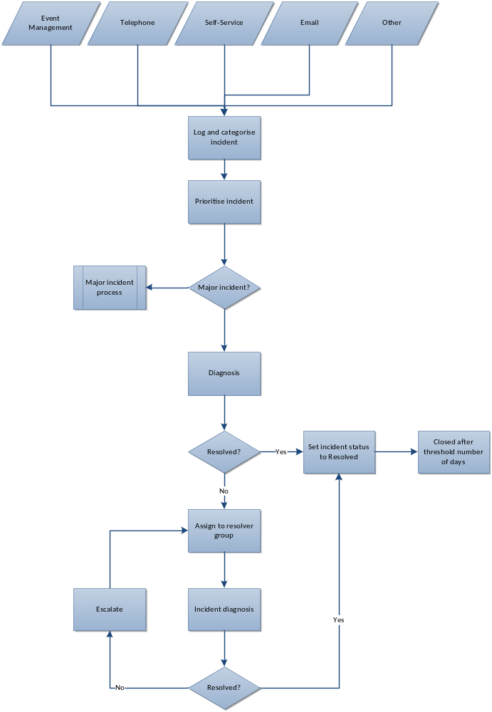

Figure 1 - Incident Management Process

Process Narrative

Log and Categorise Incident

An Incident will be recorded against the user that raises it. Three levels of classification will be used for most incidents. Where possible standard incident descriptions are defined which pre-set the description, priority, and classification of the incident. This will reduce variation in the logging of incidents and ensure more accurate reporting.

For incidents reported over the telephone there is an opportunity for First-Line to ensure that sufficient detail is obtained so that a good explanation of the incident can be recorded within the Service Desk system. If the incident is reported via self-service however all the required detail may not be provided by the user. First-Line will then need to contact the user and request the additional information.

Whichever method is used to report the incident, First-Line will have available a set of scripts which set out the information required according to the subject of the incident. For example for a situation where the user can’t print the name of the printer will be required.

Prioritise Incident

Incidents will be logged with one of the following priorities:

Priority | Definition | Target Response | Target Resolution
1 | Major Incident | 10 minutes | 4 hours
2 | High | 30 minutes | 8 hours
3 | Medium | 1 hour | 2 days
4 | Low | 4 hours | 5 days
5 | Planning | 2 days | 10 days

These priorities are calculated based on the Urgency and Impact that the incident is assigned as follows:

Impact/Urgency | High | Medium | Low
High | 1 | 2 | 3
Medium | 2 | 3 | 4
Low | 3 | 4 | 5

The Analyst must initially assess the impact and urgency (and therefore resulting priority) of the call to determine whether it represents a major incident. If it does, the Major Incident Management process is invoked.

Incident Diagnosis

If it is established that the call is a new incident that is not major, then the Service Desk Analyst will attempt to resolve the user’s issue immediately, often using remote control tools.

The Knowledgebase may be referenced for articles that detail resolutions for incidents with similar symptoms. Known Errors and Workarounds that relate to problems that have been diagnosed but not yet fixed may also be found in the Knowledgebase.

Once an Incident has been logged, all activities performed with respect to that incident should be recorded as Actions e.g. adding notes, referring to supplier. Where appropriate, the option to send an email to the user should be selected in order to keep the user informed of progress at all times.

Incident Escalation

Where the incident cannot be resolved at first line, it is assigned to an appropriate second line resolver group. This may be internal or external to [Organisation name].

The incident database should be searched to see if any similar incidents have been successfully resolved previously.

When working on an incident, technicians should temporarily assign it to themselves so that other technicians are aware that they are working on it.

If the current resolver group cannot resolve the incident the technician may opt to escalate it further e.g. to an external supplier. In this case the incident remains with the internal resolver group and it is the technician’s responsibility to ensure that the incident is updated on a regular basis based on feedback from the external supplier.

Resolve and Close the Incident

Upon resolving an incident clear detail of the resolution must be entered and the category under which it was logged checked to ensure it is still correct.

The user will be automatically emailed to inform them of resolution and a link to a satisfaction survey will be included in x% of cases.

The user should be contacted before setting the incident to the resolved status to confirm that this is their understanding also. If the user cannot be contacted after reasonable efforts (which should be recorded on the incident record), the incident should be set to resolved.

[OR]

There is no explicit requirement to contact the user before resolving the incident. It is expected that the user will contact the Service Desk if the incident has not been resolved to their satisfaction. Resolved incidents will be automatically closed after 5 days.

Stopping the Clock

The length of time it takes to resolve an incident is of course a key metric when determining the level of service being delivered. There are times however when the duration of the incident is affected by circumstances outside the control of [Service Provider] and therefore the elapsed time does not represent a true picture of service provided. In this situation it is acceptable to stop the clock and restart it again when control is once again within [Service Provider].

These circumstances are:

- Waiting for further information from the user without which diagnosis and resolution of the incident cannot progress e.g. which printer is not working, what do they mean by “broken”
- Waiting for the user to test whether the incident is resolved

Where the incident is waiting for information or assistance from a third party supplier this will not stop the clock as it is a part of the service provided by [Service Provider]. Contracts with suppliers should be aligned with the SLA so that they provide support within the SLA timeframe agreed with the users.

Golden Rules

During the diagnosis and resolution of an incident there are a number of actions that should always be carried out as a matter of course by each member of [Service Provider]. These are:

- Always update the incident record with actions carried out, even if it is only the fact that the user was telephoned without success. This shows activity on the incident which is useful to First Line if the user calls for an update
- Always set the incident to the Resolved status as soon as this is thought to be the case so that a fair picture is obtained from later service level reporting
- Be descriptive when entering the resolution text so that the incident record may be useful in future as part of the knowledge base. “Fixed” or “Resolved” is not acceptable
- Make sure the incident is set to the correct status at all times, including when waiting for feedback from the user as the clock will be stopped at this point

Following these rules will mean that a clear, concise picture of the status of every incident is always available.

Process Roles and Responsibilities

- Tier 1 Analyst

  - Receives communications from users regarding incidents.
  - Logs incidents in the incident management system
  - Attempts to resolve the incident.
  - Escalates incident where necessary.

- User

  - Provides information regarding the incident
  - Keeps the IT Service Desk informed of any changes with regard to the incident (e.g. it starts working)
  - Carries out any re-testing requested by the IT Service Desk

- Service Desk Manager

  - Controls allocation of resources within the Service Desk
  - Acts as management escalation point for Service Analysts and users when required

- Resolver group

  - Diagnoses and resolves escalated incidents
  - Liaises with third parties where required

RACI Matrix

The table below clarifies the responsibilities at each step using the RACI system, i.e.:

R= Responsible A= Accountable C= Consulted I= Informed

Role: | [Service Analyst] | User | Service Desk Manager | Resolver Group
Step
Log and categorise incident | R | C | A
Prioritise incident | R | C | A
Incident diagnosis | R | C | A
Incident escalation | R | I | I | C
Resolve and close incident | R | I | A | R
Reporting | C | I | A/R | I

Reporting

Reports on Incidents will be produced on a monthly basis and consolidated into the IT Service Report every quarter.

Many of the reports are produced as part of the Problem Management process to try to identify particular areas that need to be investigated further.

Reports specific to Incident rather than Problem Management are:

- Number of incidents logged by month.
- Breakdown of incident priorities
- Performance against SLA targets

Conclusion

The successful transition of the existing Helpdesk to a more proactive and centralised Service Desk will return major business benefits to both [Service Provider] and its customer base. By clearly understanding our customers and their business needs, we can tailor our services to meet the demand more fully. This enhanced service provision is heavily reliant upon a solid foundation, namely the Service Desk.

The acid test of this transformation must be the customer perception of the service delivered and its contribution to the overall performance of the organisation.

